Model and Simulation of PrimeTea & Samgyup on The Go Bucandala: A Samgyupsal and Milktea Business.

John Rupert Pamintuan

*Technological University*

*of the Philippines*

Jairus Ivan Iscala *Technological University*

*of the Philippines*

Juan Patrick Gallardo

*Technological University*

*of the Philippines*

Jinn Alano Dilag

*Technological University*

*of the Philippines*

***Abstract* – As business in the midst of the pandemic began to uprise than before the pandemic, and since the pandemic caused many businesses and small establishments to closed temporarily or permanently. Business owners need to take a risk and planned for opening a business during the pandemic as it may bear extra expenses to develop a business and to secure the cleanliness and follow the guidelines of local government in developing a business. This paper presents the method and process of developing a Food business that uses simulation and modeling to monitor the randomness of the customers in the establishment. The Discrete Event Simulation have advantages and disadvantages and the researchers need to know the problem as it is needed to select the right model.**

**Keywords – *Simulation Method, Modeling Method.***

1. **INTRODUCTION**

**BACKGROUND OF THE STUDY**

The ‘Strategic preparedness and response plan’ by WHO includes the health measures that all countries had to prepare for and respond to this pandemic. This plan covers

what we have learned about the virus so far and aims to transform this information into strategic action that can guide all national and international partners while developing national and regional operational plans. Coordination, planning, and monitoring at the country level; Risk communication and community participation; Surveillance, quick response teams, and case investigation; Entry points; National laboratories; Prevention and control of infection; Situation management; Operational support and logistics.

The implementation of these measures caused the closure of workplaces and educational institutions, and temporary restrictions in travels and social meetings. Flexible working from home and online meetings have become standard practices nowadays. However, people who work in the food industry do not have work from home option hence they need to keep their typical office routines [1].

The PrimeTea & Samgyup on the Go Bucandala is a Samgyupsal and Milktea business located at Bucandala, Imus City Cavite. It is a Samgyupsal and Milktea business that serve some kinds of Korean dishes and foods like, kimchi, fish cake, pork ramyeon and more. It also has choices and packages, it has a package named like Navios Samgyupsal Set B(Beef), this is a samgyupsal with a meat served with beef worth 599.00 pesos, another package is Navios Samgyupsal Barkada Set it is a samgyupsal with a meat served with beef and pork, but it is for a bigger set of customers and it cost for about 899.00 pesos. They also accommodate additional or add-ons with their orders like, barbeque sauce, gochujang sauce, ssamjang sauce, kimchi sauce, honey garlic sauce and many more. PrimeTea & Samgyup on the Go Bucandala, also serve milktea like winter melon milktea.

The PrimeTea & Samgyup on the Go Bucandala is also a new developed business in which it is developed during this pandemic on around last quarter of the year 2021. As the business is currently new, problems are highly to encounter. The researchers found out that, since the business is new there are currently few customers who go to the store and order their food. With the probability of 1 – 2 customers per hour, the researchers decide to create a model and simulate the upcoming happenings in the restaurant business, as this is their first time in doing food business the researchers may come up of a solution to the problems they may encounter.

**OBJECTIVES OF THE STUDY**

The study Model and Simulation of PrimeTea & Samgyup on the Go Bucandala: A Samgyupsal and Milktea Business, aims to model and simulate the average number of customers who arrive in the business per hour, and to know what might be the cause and solution that the researchers may suggest for the business to improve. As the model and simulation may not be accurate to the real-time events inside the food business it is safe to assume that the suggestions of the researchers may help the food business to grow and it is up to the owner to took it into consideration when it comes to planning in ensuring the business will improve.

**BOUNDARIES OF THE STUDY**

The model and simulation of PrimeTea & Samgyup on the Go, may not be 100% accurate with the current facilities and process in real-time with the known business, but the researchers will try to create a model and simulation on par with the known business to accurately compare and analyze the probable problems and solutions that the researchers may suggest.

**INPUT AND OUTPUT DATA REQUIREMENTS**

In the required input requirements of the model and simulation of PrimeTea & Samgyup on the Go are the number of customers who arrived in the business per hour, as in this data the model will be

conceptualize and the simulation will be based on. Another is the time how long does the food will cook and served to the customers per minutes, this input may be optional as the main goal of the study will be based on the number of customers who will arrived per hour, but as this is optional it will be important to include as it may be an option to look upon by the business owner if the problem uprise with it.

**ANIMATION REQUIREMENTS**

The researchers will develop a modelling and simulation of PrimeTea & Samgyup on the Go Bucandala on a Software Application called SIMIO. The minimum requirements of the application are Pentium or faster processor. 4GB or more RAM, 500MB for minimum installation or more as downloading of the resources are many, 128MB integrated graphics compatible with DirectX 9.

**PROJECT TIMELINE**

The researchers have a difficulty in finding a business to studied, that’s why it took march and April to planned, but then one of the researchers implied that he has a friend who has a business and they are willing to partake for the study, in the months April and May the researchers gather the following data to be used in modelling and simulating the business. In the month June the researchers began to build the right model for the business and also simulate the model to know the comparison of the data to the outputted data of the model.

TABLE 1

**PROJECT TIMELINE OF THE PROPOSED STUDY**

|  |  |  |  |  |  |
| --- | --- | --- | --- | --- | --- |
|  | March | April | May | June | July |
| Planning |  |  |  |  |  |
| Collecting Data |  |  |  |  |  |
| Building Model |  |  |  |  |  |
| Simulate the Model |  |  |  |  |  |
| Verify, Validate and Analysis |  |  |  |  |  |
| Submit |  |  |  |  |  |

1. **SIMULATION MODELING METHODS**

The researchers build a restaurant queuing simulation model to evaluate the average number of customers who arrived and eat at a restaurant business. The simulation model was initially validated using the data from the receipt of orders that the researchers gathered from the business owner and was tested from a different scenario (preparedness of the business in a change of average number of customers). In the following the researchers describe how to simulation inputs were used to understand the model.

1. *Input analysis*

The data that the researcher gathered are from a Samgyupsal and Milktea Business, that has 1 person for cashier, 1 person for cook, and 1 person for server of the foods. The data gathered by the researchers are also the average number of customers who arrived per hour. Optionally gathered are the average cooking time of meals per minute, and the average eating time of customers per minute.

TABLE 2

**TIME AND AVERAGE NUMBER OF CUSTOMERS PER HOUR**

|  |  |
| --- | --- |
| Time | Average Number of Customers per hour |
| 10:00am – 11:00am | 2 |
| 11:00am – 12:00nn | 2 |
| 12:00nn – 1:00pm | 2 |
| 1:00pm – 2:00pm | 4 |
| 2:00pm – 3:00pm | 2 |
| 3:00pm – 4:00pm | 3 |
| 4:00pm – 5:00pm | 2 |
| 5:00pm – 6:00pm | 2 |
| 6:00pm – 7:00pm | 3 |
| 7:00pm – 8:00pm | 1 |
| 8:00pm – 9:00pm | 2 |
|  | 25/25 total |

In the Table 1 shown above is the average number of customers per hour, according to the table there an average of 1 to 3 customers who arrived in the business premises per hour. The average time of cooking a samgyupsal side dish according to the cook is 10 to 15 minutes then the average waiting time for the food and eating of the food is around 20 to 30 minutes.

1. *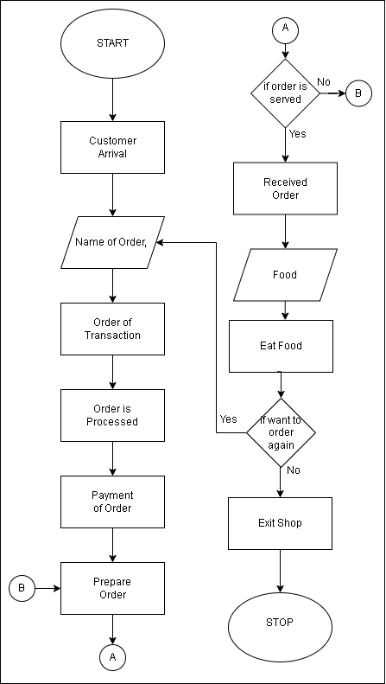DES model conceptualization*

Name of order

*Figure 1. Flow of Customers in the Samgyupsal and Milktea Business on a Daily Basis*

A DES model based on the average number of customers who arrive in the Samgyupsal and Milktea Business was developed using personal edition simulation software SIMIO. The scope of the system and the patient flow is described as follows. Customers arriving in the restaurant will fall in line with the queue and will order the food. The time needed for the food to be prepared will be based on the time given by the cook on how long will it prepared. There will be one cook per one order process, it means one cook will be on service if one order is been done. After the cashier got the Name of the Order, the order will be a transaction and will take by the cashier, then the order will be processed by the cashier and the order will be paid. After paying the order, the order will be prepared by the cook and the order will be served to the customer. If the order is not served the customer will wait for its order. The order will be Received by the customer if the server will serve the food. If the customer wanted to order again, the customer can order again by going to the cashier, and giving the name of the order to the cashier. If not, the customer will exit the shop.

1. *Model Validation*

The validity of the model was tested with the given data that the researchers gathered from the samgyupsal and milktea business. The gathered data in the TABLE 2 was used to compare the with the output of the DES model/

1. *Comparative Analysis*

The researchers constructed 10 scenarios with 100 replications to be tested with the assumptions to the ordered products of each customer. The objective was to determine and simulate the average number of customers who arrive in the business per hour in a day, and to know what might be the cause and solution that the researchers may suggest for the business to improve. The confidence level is 95% with the 75% Upper percentile and 25% Lower Percentile. The scenarios created in the experiment corresponds the different scenarios that might happen inside the establishment, like in the OrderFood, the customer may order 1 food, in the CookFood, the cook may cook 1 food, and the ServeFood may serve 1 food. These scenarios can be different in any person and anytime, it can be a customer may order 3 foods, the cook 2, and may serve 2 foods.

For the arrival of the customers was simulated to reflect to the average number of customers per hour in a daily basis.

1. **RESULTS**
2. Validation results

The researchers ran the model for 100 replications for the simulation to ensure a narrow confidence interval. The researchers use the gathered data from the Samgyupsal and Milktea business, according to the data gathered the average number of customers who arrive in the business per hour are 2 and the maximum is 4 persons. According to the Figure 2, The simulation yielded the average of 1.6629 and a maximum of 4. It is determined that the model can support the system. The researchers validate that the average number of the arriving customers in the Samgyupsal and Milktea Business conform to the real data.

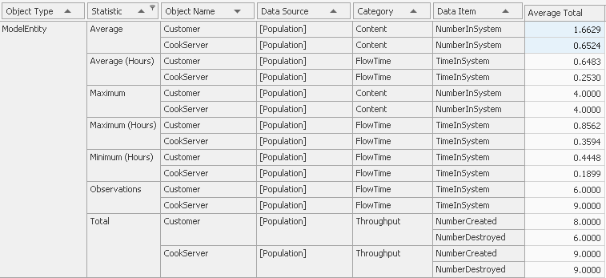

*Figure 2. Flow of Customers in the Samgyupsal and Milktea Business on a Daily Basis*

1. T-Test table

The researchers also computed the average number of the customers that are arriving in the business, per day, it yielded the results in the Figure 3, below. With the t-test score of 0.95517312 or estimated by 0.96, and with the sum of the average data by 25 per day, the sum of the average in simulation yielded 24.8459 or 25. This tells that the model created is validated and reflect the real-life establishment, as because the closer the t-test score to 1, the accepted value would be a p-value of 0.05% thus the Ho is accepted or the null hypothesis is accepted and there is no significance difference with the model, and the real-life establishment.

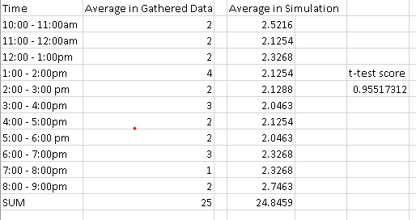

*Figure 3. T-Test Table of the Mean Customers in the Samgyupsal and Milktea Business on a Daily Basis*

1. Simulation results

With the experimentation scenarios being tested, the scenarios explained in the Comparative Analysis, the output of each scenario is the average number of the arriving customers in the Samgyupsal and Milktea Business ranges from 1.5564 to 1.8030 and with the maximum of ranges from 4.1900 to 4.6900, this means that with the changing of the Capacity in the system the business can handle at most the customers at the average, but as the customers accumulated exponentially the arriving customers increased and the business might not handle the situation, with its current cooks and servers. While the cooks and servers can only process and serve one customer at most, as it has only 1 person on the cashier and 1 person doing cooking and 1 for serving. The results of each Scenario is different with other as this suggests that this model replicate the possible scenarios happening in real-life, the researchers decides that even with the recent changes with the Capacity in the experiment, the output will change but the establishment can handle it but in the long run the establishment needs to hire more worker, as the lack of service workers is one of the factors that may rise.

1. **CONCLUSION**

A, Limitations and future work

The researchers conclude that there may not be a problem with the average arriving customers in the samgyupsal and milktea business, because as the time passes many of the customers will began to go to this business to buy and order food, but then as the time passes, the business premises may not be able to serve the customers properly as the business lack the necessary workers that it need in to support larger amounts of customers. As this is a starting food business, this might be not a problem at first but as long as there are customers who ate at the shop, the average number of the arriving customers may increase. Thus, the researchers suggests that the business might need to increase their workforce for them to manage serve large amounts of customer, and also to accommodate more tables and chairs for them.

This simulation model provides a helpful information for the businesses to know what might be the problems with their system or on how they run their establishment. By integrating the DES model, the projection of the average number of arriving customers may be analyzed ahead of time. Through this study in can grant a lead time for mitigating financial errors in the business.

In the simulation model, the researchers focused mainly on the average of the arriving customers in the business, and optionally with the utilization of the time how long the process of cooking and serving it may vary. As there is a need to increase the workforce of the business to accommodate larger number of customers, thus this information may be helpful to the owner.

1. **REFFERENCE**

[1] Serpil Aday, Mehmet Seckin Aday, Impact of COVID-19 on the food supply chain, Food Quality and Safety, Volume 4, Issue 4, December 2020, Pages 167–180, <https://doi.org/10.1093/fqsafe/fyaa024>